Mastering
Blocking & Stuttering
With Neuro-Semantics®
“An Introduction”

Bobby G. Bodenhamer, D.Min.

Presenter

Opening Remarks:

Neuro-Semantics has proven quite effective for many PWS.

Not all PWS have obtained fluency with these tools.

This model is not a quick cure though some have found fluency rather quickly.

We are providing realistic hope for a lot of PWS who had given up hope for recovery.

Most who gain fluency must work and work hard for several months and sometimes longer.

The Presentation

Please hold your questions.

I will allow time for questions and comments at the end of my presentation.

I wish to provide as much information as possible within the limited time frame provided me.

I hope that many of your questions will be answered during the presentation.

In Neuro-Semantics We Believe –

That cognition (thinking) explains why most PWS can speak fluently in some contexts and not speak fluently in other contexts?

That at its onset, blocking & stuttering could have physical and/or genetic components.

That the “only” logical explanation for the same mind-body system speaking fluently in some contexts but not others contexts is in cognition.

In Neuro-Semantics We Believe –

That the fear of looking like a fool or being vulnerable, etc., because of blocking and stuttering, dramatically increases blocking and stuttering?

That when the PWS develops a healthy view of themselves as an innate person of worth in spite of how they speak, blocking & stuttering will dramatically dissipate and eventually disappear?

(Yes, we have several case studies of successes. However, as of yet, we do not have clinical trials supporting our work.)

In Neuro-Semantics We Believe –

That once the PWS develops a strong sense of inner self worth, the PWS gains control of their speech.

That by having a strong sense of inner self-worthiness, the PWS empowers themselves not to care what others may or may not think of them because of the blocking & stuttering.

That once the PWS is esteeming and empowering themselves to the point of not caring what others may or may not think of them, then the blocking strategy of the mind-body system doesn’t activate but the fluency strategy activates and the PWS speaks fluently.

How Does
Blocking & Stuttering Happen?

How does the brain learn to block/ stutter in certain situations and not in others?

What structural components of the brain function in order to create blocking/ stuttering?

How do the structural components of the brain function together in order to create blocking/ stuttering?

Disfluency to Adult Blocking

We believe that blocking begins in childhood.

It begins when some “disfluency” gets named, labeled, as something bad and unwanted.

Early learnings in childhood and later adult reinforcement “lock” in the disfluency which then becomes an adult blocking.

1. We believe that the Meanings given to those early experiences around disfluency determines:

Your concept of your Self.

How you understand your sense of Power and Resourcefulness and hence whether or not you have control over how you speak.

Your relationship with Others in the context of blocking & stuttering.

Etc.

Typical Meanings for PWS –

“I don’t want to look like a fool.”

“I am flawed.”

“I am out of control.”

“I have always blocked and I always will.”

“I can’t measure up to the expectations of other people.”

“What other people say about me is my ‘truth’.”

Meaning – To “Hold in Mind”

What we hold in mind becomes our “meaning” precisely because we hold it in mind and use it as our reference structure.

First, we hold such meanings in our mind by creating movies in our head.

Second, we hold meanings in our mind mostly through language – words that give “meaning” to our mental movies.

The Importance of Words –

We provide meaning to our movies with words. These two combined are the “stuff” of thoughts.

But we don’t stop there – we keep having thoughts about thoughts.

It is in this way that we create the “meanings of our mind” that through interaction with our bodies produce our “states.”

Blocking and stuttering are created this way as is all our states of mind-body.

Emotions Embedded in the Body

All of these negative thoughts become “embodied” – we are a mind-body system.

These negative emotions find expression in those muscle groups controlling breathing and speaking.

Modern neuro-sciences confirm our suspicion that emotions can and do find expression in particular areas of the body.

Blocking is a “Panic Attack.”

A Panic Attack is a discrete period in which there is the sudden onset of intense apprehension, fearfulness, or terror often associated with feelings of impending doom. During these attacks, symptoms such as shortness of breath, palpitations, chest pain or discomfort, choking or smothering sensations and fear of going “crazy” or losing control are present.
(From the DSM-IV)

Thoughts about Thoughts –

We just keep having thoughts about thoughts.

And by doing this we layer our mind-body states.

We create both our positive and our negative states in exactly the same way.

The brain doesn’t care whether or not you feed it garbage as does the stomach.

All the “higher levels” fire at once causing a “panic” attack issuing in a “block.”

Creating a ‘Gestalt’ of Fear & Anxiety

The second thought changes the first thought, etc.

We continually have thoughts about thoughts.

As we do, each time we have a thought about another thought, the second thought will change the first thought.

Bateson – “Higher levels modulate lower levels.” Steps to an Ecology of Mind

An Experiment with Meta-States

Get a thought of fearing some future task.

Access a thought of faith or courage.

Apply faith/courage to fear.

Knowing how to do this is foundational to knowing how to run your own brain and manage your own states.

Applying “Courage/ Faith” to the “Fear of Blocking”

Changing Meaning by Changing Beliefs

What is the difference between a thought and a belief?

Can you hold a thought in your mind that you do not believe?

How do we change a thought into a belief?

A belief is a thought that we say yes to.

Meta-Yes/ Meta-No Pattern

We change a limiting belief at the base level by saying “no” to it.

Make sure your desired belief is ecological for you.

Meta-stating a limiting “belief” enables us to de-commission old programs.

Meta-Yes/ Meta-No Pattern

Access a limited belief and “get a strong “no!”

Meta “no” the limiting belief.

Access a strong and robust “yes.”

Meta “yes” the enhancing belief.

Yes, yes it repeatedly and put it into the future.

Drop Down Through Game

Identify the experience or emotion (Problem State).

Step into the experience.

Drop down through the experience.

Confirm the emptiness.

Meta-State each problem state.

Test.

New Book
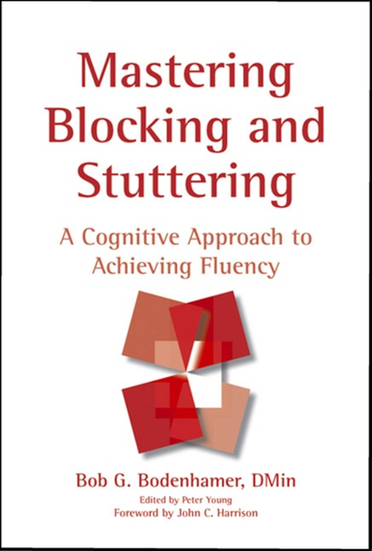

Contact Information –

Bobby G. Bodenhamer, D. Min.
1516 Cecelia Dr
Gastonia, NC 28054
704.864.3585
bobbybodenhamer@yahoo.com

www.masteringstuttering.com
www.neurosemantics.com

Articles by several authors

Free Patterns and Change Techniques

Books by L. Michael Hall, Ph.D. and Bobby G. Bodenhamer, D.Min.

Video Tapes: www.nlp-video.com – Training Tapes for NLP and NS Trainings including the Mastering Blocking & Stuttering 5-Day Workshop.

Training Opportunity –

Workshop: 5-Day Mastering Blocking & Stuttering in London England

Dates: September 14-18, 2005

Contact: Phoebe Butterwick, SLP

Phoebeflora@hotmail.com
01428 682599

Trainer: Bobby G. Bodenhamer, D.Min.

Guest Facilitators:

John Harrison and Alan Badmington – Inspirational experts on stuttering who have gone beyond their own stammering so it is no longer in their minds.

Debbie Mason and Mike Jones – Master NLP Practitioners with special interest in stuttering (Debbie is a speech pathologist and Mike has overcome stuttering.

To find out more about the workshop visit:

http://www.neurosemantics.com/Stuttering/Mastering_Stuttering.htm

